MSB 100: MYCOLOGY OVERVIEW
- The study of fungi.
- Fungi inhabit almost every niche in the environment and humans are exposed to these organisms in various fields of life.
Beneficial effects of fungi
- Decomposition - nutrient and carbon recycling.
- Biosynthetic factories. The fermentation property is used for the industrial production of alcohols, fats, citric, oxalic and gluconic acids For instance, Sacharomyces cerevisiae.
- Important sources of antibiotics, such as Penicillin (secondary metabolite).
- Model organisms for biochemical and genetic studies. Eg: Neurospora crassa
- Saccharomyces cerviciae is extensively used in recombinant DNA technology, which includes the Hepatitis B Vaccine.
- Some fungi are edible (mushrooms).
Harmful effects of fungi
- Destruction of food, paper, and cloth.
- Animal and human diseases, including allergies.
- Toxins produced by poisonous mushrooms and within food (Mycetism and Mycotoxicosis).
- Plant diseases.
- Spoilage of agricultural produce such as vegetables and cereals in godowns.
- Damage to products such as magnetic tapes and disks, glass lenses, marble statues, bones and wax.

A fungal cell (Eukaryotic cell)
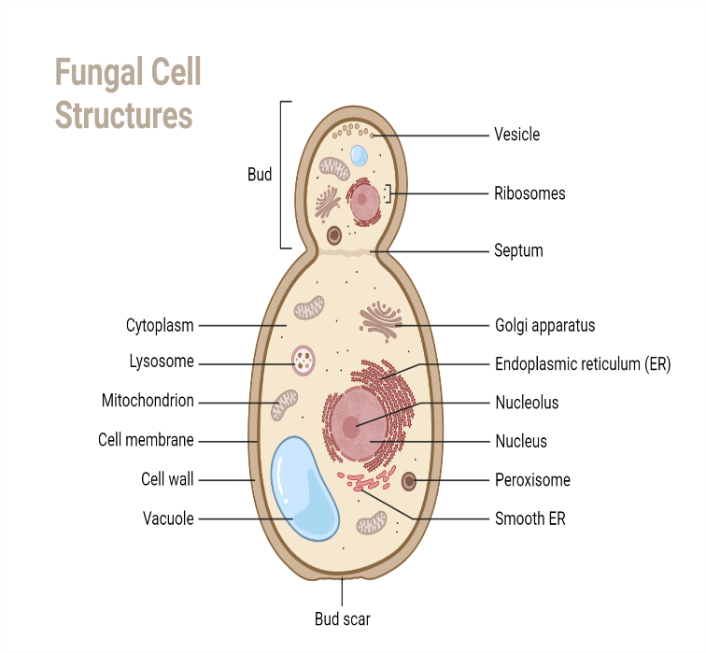
Properties of fungi
- They are eukaryotic; cells contain membrane bound cell organelles including nuclei, mitochondria, golgi apparatus, endoplasmic reticulum, lysosomes etc.
- Fungal cell membranes have ergosterols instead of cholesterol as the major sterol and possesses 80S ribosomes.
- Have a rigid cell wall made of chitin and are therefore, non-motile, a feature that separates them from animals.
- Are chemoheterotrophs - saprophytic (require organic compounds for both carbon and energy sources); lack chlorophyll and are therefore, not autotrophic.
- Fungi are osmiotrophic; they obtain their nutrients by absorption.
- They obtain nutrients as saprophytes (live off of decaying matter) or as parasites (live off of living matter).
- Typically reproduce asexually and/or sexually by producing spores.
Fungal structure
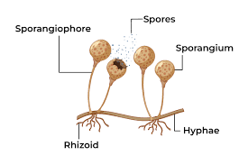

Classification of fungi
There are alternate and more practical approaches, one based on sexual reproduction and the other based on morphology of the thallus (vegetative structure).
- Based on Sexual reproduction
- Zygomycetes: reproduce via production of zygospores.
- Ascomycetes: produce endogenous spores called ascospores in cells called asci.
- Basidiomycetes: produce exogenous spores called basidiospores in cells called basidia.
- Deuteromycetes (Fungi imperfecti): fungi that are not known to produce any sexual spores (ascospores or basidiospores).
- Based on Morphology
- Moulds (Molds): Filamentous fungi at room temperature Eg: Aspergillus sps, Trichophyton rubrum
- Yeasts: Single celled cells at body temperature Eg: Cryptococcus neoformans, Saccharomyces cerviciae
- Dimorphic Fungi: Fungi existing in two different morphological forms at two different environmental condition - temperature. They exist as yeasts at 37oC and as moulds in their natural habitat at room temperature. Eg: Histoplasma capsulatum, Blastomyces dermatidis, Paracoccidiodes brasiliensis, Coccidioides immitis.

- On the basis of nutrition
- Saprophytic – The fungi obtain their nutrition by feeding on dead organic substances. Examples: Rhizopus, Penicillium and Aspergillus.
- Parasitic – The fungi obtain their nutrition by living on other living organisms (plants or animals) and absorb nutrients from their host. Examples: Taphrina and Puccinia.
- Symbiotic/mutualism – These fungi live by having an interdependent relationship with other species in which both are mutually benefited.
Morphology of fungi/Fungal cell structure
- All fungi have typical eukaryotic morphology.
- They have a rigid cell wall composed of chitin, which may be layered with mannans, glucans and other polysaccharides in association with polypeptides.
- Inner to the cell wall is the plasma membrane that is a typical bi-layered membrane.
- Fungal membranes possess ergosterol in contrast to cholesterol found in other cells.
- The cytoplasm consists of various organelles such as mitochondria, golgi apparatus, ribosomes, endoplasmic reticulum, lysosomes, microtubules and a membrane enclosed nucleus.
- The nucleus possesses paired chromosomes.
Moulds
- The thallus of mould is made of hyphae, which are cylindrical tube like structures that elongates by growth at tips.
- A mass of hyphae is known as mycelium.
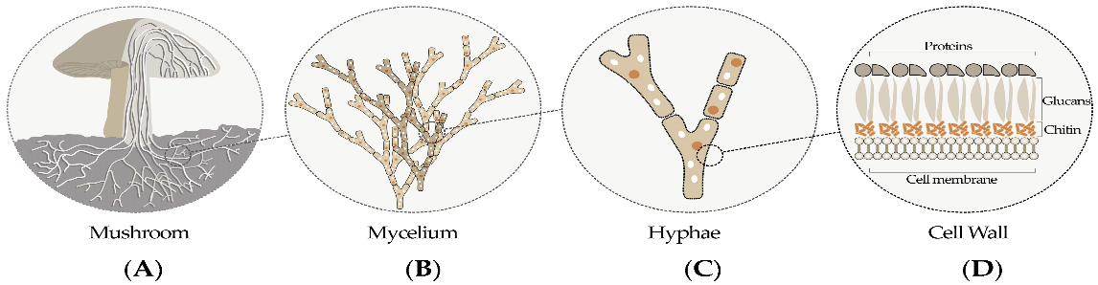
- It is the hypha that is responsible for the filamentous nature of mould.
- The hyphae may be branched or unbranched.
- They may be septate or aseptate/coenocytic - Hyphae usually have cross walls that divide them into numerous cells. These cross walls, called septa, have small pores through which cytoplasm is continuous throughout the hyphae.
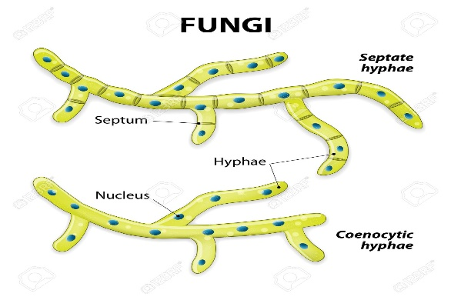
Mycelium are of three kinds:
- Vegetative mycelium are those that penetrates the surface of the medium and absorbs nutrients.
- Aerial mycelium are those that grow above the agar surface
- Fertile mycelium are aerial hyphae that bear reproductive structures such as conidia or sporangia.
Yeasts
- Yeasts are unicellular spherical to ellipsoid cells. They reproduce by budding, which result in blastospore (blastoconidia) formation.
- In some cases, as the cells buds, the buds fail to detach and elongate thus forming a chain of elongated hyphae like filament called pseudohyphae.
- This property is seen in Candia albicans.
- Some yeast such as Cryptococcus and the yeast form of Blastomyces dermatatidis produce polysaccharide capsules.
- Capsules can be demonstrated by negative staining methods using India ink or Nigrosin.

Pathogenesis of fungal diseases (Mycoses)
Transmission routes are conserved for microorganisms.
Fungi are predominant pathogens in individuals with a suppressed immune system
Disease Development Process – Incubation period – Prodromal period – Phase of illness – Phase of Decline – Convalescence phase
Pathogenesis Process – Exposure – Entry – Colonization (infection in cases of successful colonization by pathogens) - Disease
- Classification of human mycoses
Fungal infections may be classified according to the tissues infected, as well as by specific characteristics of organism groups.
- Superficial mycoses
- Limited to the very superficial surfaces of the skin and hair.
- They are non-destructive and of cosmetic importance only.
- The clinical infection termed Tinea/Pityriasis versicolor is characterized by discoloration or depigmentation and scaling of the skin.
- Tinea nigra refers to brown or black pigmented macular patches localized primarily to the palms.
- Cutaneous mycoses
- Cutaneous mycoses are infections of the keratinized layer of skin, hair, and nails.
- These infections may elicit a host immune response and become symptomatic.
- Signs and symptoms include itching, scaling, broken hairs, ringlike patches of the skin, and thickened, discolored nails.
- The Dermatophytes are fungi classified in the genera Trichophyton, Epidermophyton, and Microsporum.
- Subcutaneous mycoses
- Subcutaneous mycoses involve the deeper layers of the skin, including the cornea, muscle, and connective tissues.
- The fungi gain access to the deeper tissues usually by traumatic inoculation (Sporothrix schenkii – kayaba thorns) and remain localized, causing abscess formation, non-healing ulcers, and draining sinus tracts.
- The host immune system recognizes the fungi, resulting in variable tissue destruction and frequently epitheliomatous hyperplasia.
- Systemic Mycoses
- The endemic mycoses are fungal infections caused by the classic dimorphic fungal pathogens Histoplasma capsulatum, Cryptococcus neoformans, Blastomyces dermatitidis, Coccidioides immitis, Coccidioides posadasii, and Paracoccidioides brasiliensis.
- These fungi exhibit thermal dimorphism (exist as yeasts or spherules at 37° C and molds at 25° C) and are generally confined to geographic regions where they occupy specific environmental or ecological niches.
- Opportunistic Mycoses
- The opportunistic mycoses are infections attributable to fungi that are normally found as human commensals or in the environment.
- Virtually any fungus can serve as an opportunistic pathogen, and the list of those identified as such becomes longer each year.
- The most common opportunistic fungal pathogens are the yeasts Candida spp. and Cryptococcus neoformans, the mold Aspergillus spp., and Pneumocystis jirovecii.
• Entry
- Fungi infect the body through several portals of entry.
- The first exposure to fungi that most humans experience occurs during birth, when they encounter the yeast C. albicans while passing through the vaginal canal.
- During this process the fungus colonizes the buccal cavity and portions of the upper and lower gastrointestinal tract of the newborn, where it maintains a life-long residence as a commensal.
- Entrance to the host generally occurs through the mucosa in orifices like the oral cavity, nose, eyes, genitalia, anus, or open wounds.
- Other fungi that have been implicated in human diseases come from exogenous sources, where they exist as saprobes on decaying vegetation or as plant parasites.
- Fungi rarely cause disease in healthy, immuno-competent hosts.
Dissemination
- Disseminated fungal diseases usually indicate a breach in host defenses.
- Such a breach may be caused by endocrinopathies or immune disorders, or it may be induced iatrogenically.
- Effective management of fungal infection requires a concerted effort to uncover and correct the underlying defects.
- Occurs via the bloodstream or the neural system to their predilection sites (target tissues)
Host factors that determine the outcome of infections
- Fungal growth is discouraged by the intact skin and factors such as naturally occurring long-chain unsaturated fatty acids, pH, competition with the normal bacterial flora, epithelial turnover rate, and the desiccated nature of the stratum corneum - the outermost layer of the epidermis.
- Other body surfaces, such as the respiratory tree, gastrointestinal tract, and vaginal vault, are lined with mucous membranes (epithelium) bathed in fluids that contain antimicrobial substances.
- Some of these membranes are lined with ciliated cells that actively remove foreign materials.
- Only when these protective barriers are breached can fungi gain access to, colonize, and multiply in host tissues.
- Fungi gain access to host tissues by traumatic implantation or inhalation.
- The severity of disease caused by these organisms depends upon the size of the inoculum, magnitude of tissue destruction (target tissue & tissue sensitivity), the ability of the fungi to multiply in tissues, and the immunologic status of the host.
Fungal Factors that determine the outcomes of infections (Virulence features)
Molecules involved in host immune evasion.
Molecules | Function | Effect on Human Immune System
Mannans | Proper cell wall architecture | Shielding of β-1,3-glucans (antigenic) from Dectin-1 receptor (pathogenic recognition receptor)
Melanin | Mechanical strength of the cell wall, enzymatic degradation resistance and UV protection | Resistance to phagocytosis (neutrophils and the macrophages)
α-1,3-Glucan | Proper cell wall structure and architecture | Shielding of β-1,3-glucans from Dectin-1 receptor
Endo β-1,3-glucanase (enzyme) | Trimming of β-1,3-glucan segments exposed on the fungal cell surface | Reduced recognition of the yeast via Dectin-1
Transferrin Receptors | Utilizing host iron-binding proteins as a source of iron | Overcoming the host nutritional immunity of iron by the host
Pra 1 | Scavenger of host zinc | Overcoming the nutritional immunity of zinc by the host
Rod A | Cell wall hydrophobin | Diminishes host NETs (neutrophil extracellular traps) formation

Fungal structures involved in the host immune evasion.
Structure | Function | Effect on the Human Immune System
Fungal Capsule | Protection form environment and source of virulence factors | Anti-phagocytic properties, suppression of T lymphocyte proliferation, induction of the anti-inflammatory cytokine IL-10, reduction in pro-inflammatory cytokines and survival inside macrophage environment. NETs formation is impeded by the capsular component GXM
Titan-cell Formation | Protection from hostile environments | Evasion of phagocytosis and resistance to oxidative and nitrosative stresses
Asteroid Bodies | Resistance structure that protects the central yeast from the environment | Trapping of IgGs and IgMs, interfering with the proper immune system action/interfering with opsonization
Biofilm Formation | Adhesion on biotic or abiotic surfaces, survival on hostile environments | Resistance to neutrophil attack, avoids ROS triggering, and increases resistance to the antifungal activity of PBMNCs (Peripheral blood mononuclear cells)

Laboratory diagnosis of mycoses
Specimen collection: specimen collection depends on the site affected. Different specimens include hair, skin scrapings, nail clippings, sputum, blood, CSF, urine, corneal scraping, discharge or pus from lesions and biopsy.
All specimens must be transported to the laboratory without any delay to prevent bacterial overgrowth.
In case of delay specimens except skin specimen, blood and CSF may be refrigerated for a short period.
Microscopy: Microscopy is used to observe clinical specimens for the presence of fungal elements or to identify the fungus following culture.
• India Ink: Capsules of Cryptococcus neoformans can be demonstrated by this negative staining technique.
• Periodic Acid-Schiff (PAS) stain: On staining by this stain, fungal elements appear bright magenta coloured while the background stains green. It is useful in staining tissue specimens.
• Giemsa’s stain: It is particularly useful in the detection of Histoplamsa capsulatum in the bone marrow smears.
• Haematoxylin and Eosin (H&E) stain: Useful for staining tissue sections.
Culture: One of the most common media used to culture fungi in laboratory is Sabouraud’s Dextrose Agar (SDA). It consists of peptone, dextrose and agar.
Other basal media to grow fungi include Potato Dextrose Agar, Malt Extract Agar etc.
Serology (antibody-antigen specificity): Detection of anti-fungal antibody is helpful in diagnosis of sub-cutaneous and systemic mycoses.
Serologic techniques that are used include agglutination, immunodiffusion, complement fixation test, immunofluorescence, and ELISA.
Antigen detection: It is particularly useful in the diagnosis of cryptococcal meningitis from CSF specimens.
Molecular techniques: Newer techniques such as DNA hybridization, Polymerase chain reaction are useful in diagnosis of mycoses in a shorter period as well as detect those fungi that are difficult or dangerous to cultivate in vitro.

HOST-MICROBE INTERACTIONS
STERILIZATION AND DISINFECTION

