MEDICAL VIROLOGY (MSB100)

DEFINITIONS:
- A virus: a submicroscopic infectious agent replicating only inside an organism's living cells. Viruses infect all life forms, from animals and plants to microorganisms, including bacteria. Viruses may contain either DNA or RNA as their genetic material.
- Medical virology: The scientific study of viruses, structure, classification, how they cause disease, the disease they cause, and immune responses.
- Viral pathogenesis: The study of how viruses cause disease
- Cellular tropism: The specific cells and tissues in a host where a virus replicates
- Viral virulence is a virus's ability to cause illness or death in a host. It's a complex process that depends on both the virus and the host cell. Factors that affect virulence are
- Viral load: The more viral load a host has, the more harm the virus can cause.
- Host cell requirements: The virus needs a way to enter the host cell, replicate, and damage the cell.
- Host immune response: If a virus mutates, it can escape the immune system's ability to suppress it.
- Virus type: Non-enveloped viruses are usually more virulent than enveloped viruses.
- Oncogenic viruses: cancer-causing viruses e.g. Huma Papillomavirus

STRUCTURE OF A VIRUS.
- Nucleic acid is surrounded by a protein matrix - the nucleocapsid.
- Capsid surrounds the nucleocapsid and is composed of structural units called capsomers.
- Virus particles are either “naked” or have a lipoprotein structure, the envelope, which surrounds the capsid.



VIRUS SYMMETRY
Can be helical, icosahedral, (20-sided polygon), spherical or complex.

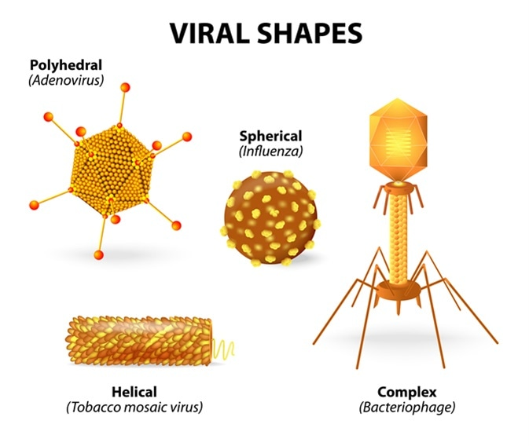
Images of selected viruses of medical importance
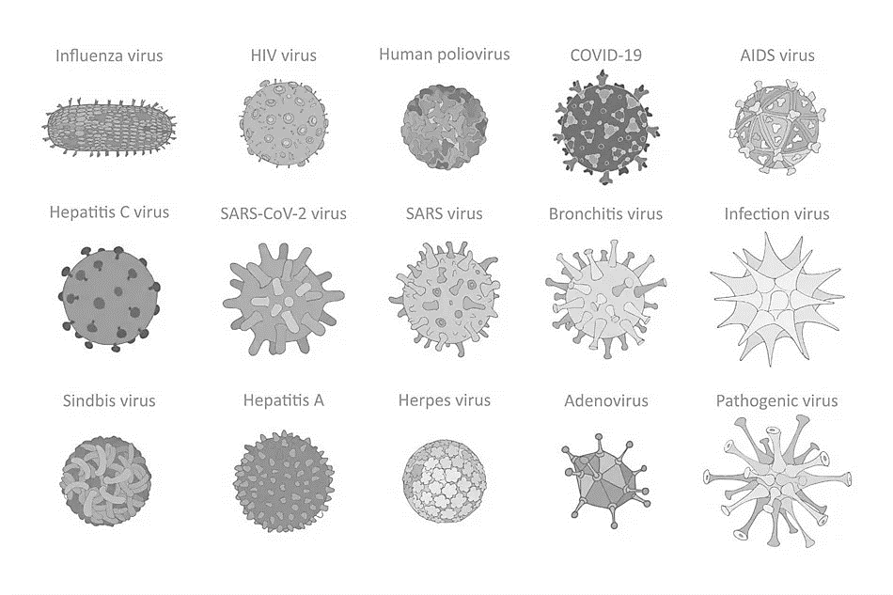

VIRAL GENOME:
- The genome of a virus may consist of DNA or RNA, which may be single-stranded (ss) or double-stranded (ds), linear or circular.
- The entire genome may occupy either:
  - one nucleic acid molecule (monopartite genome) e.g. Human Papillomavirus (cervical cancer)
  - several nucleic acid segments (multipartite genome) e.g. Lassa virus (Lassa haemorrhagic fever)
- Examples of DNA viruses: Herpes simplex virus (genital and oral ulcerations), Human Papillomavirus (cervical cancer, genital warts) and hepatitis B virus (hepatitis).
- Examples of RNA viruses: HIV (AIDS), hepatitis C virus (hepatitis, gastroenteritis) and Influenza Type A and B (Flu).

VIRAL REPLICATION:
It is also called an infectious cycle
It occurs only in living cells and involves host-cell enzymes & functions. The stages of replication are:
- Attachment or adsorption occurs when the virion comes in contact with the host cell. For example, Influenza virus type A, which causes flu, uses viral spikes (hemagglutinin—HA) to attach to the host mucosal cell’s receptor (sialic acid—a small sugar that is attached to many different proteins on the cell surface).
- Penetration occurs when the virus passes through the plasma membrane.
(1) Enveloped viruses penetrate via fusion
(2) Naked viruses can penetrate transversely. Pinocytosis is pinching through the plasma membrane, which results in entry.
- Uncoating is typically mediated by cellular proteases and results in the separation of the capsid from the viral genome
- Synthesis of early proteins. These proteins are involved in genome replication.
- Synthesis of late proteins. These proteins are used in the development of the virion's structural components.
- Assembly is the packaging of the new copies of the genome nucleic acid into the capsid proteins.
- Release of the progeny virus. The lipid envelope and glycoproteins are acquired as the progeny viral nucleocapsid buds through the membrane.

TRANSMISSION OF VIRUSES.
the process of transfer of virus into the host is referred to as TRANSMISSION and this is an important step in the life cycle of viruses. Person-to-person infections are said to be HORIZONTAL TRANSMISSION e.g. Coronavirus, Influenza and SARS - nasal secretion, coughing and sneezing increase the production of infectious aerosols. Transmission from mother to baby is put in a separate category which is VERTICAL TRANSMISSION (Marburg and Ebola virus). ZOONOSES - infection where the virus is transmitted from animals other than humans to humans Rabies virus from a dog bite.

GENERAL CATEGORIES OF VIRAL INFECTIONS
- Acute infections: are of relatively short duration with rapid recovery- common cold viruses, influenza viruses) and gastrointestinal infections e.g., Rotaviruses, Noroviruses.
- Persistent infections are where the viruses are continually present in the body - progressive encephalitis that can follow rubella
- Latent viral infection - the virus remains in equilibrium with the host for long periods before symptoms again appear, but the actual viruses cannot be detected until reactivation of the disease occurs e.g. HSV-1 (fever blisters), HSV-2 (genital herpes), and VZV (chickenpox-shingles).
- Chronic virus infection, the virus can be demonstrated in the body at all times and the disease may be present or absent for an extended period of time e.g. hepatitis B (caused by HBV) and hepatitis C (caused by HCV)
- Slow infections are ones in which the infectious agents gradually increase in number over a very long period during which no significant symptoms are seen AIDS (caused by HIV-1 and HIV-2)

SPECIMEN COLLECTION, TRANSPORT, AND PROCESSING IN A VIROLOGY LABORATORY
1. Time of collection. Specimens for viral identification are best collected during the time of the first presentation of symptoms. Virus titers (concentration of virus) are usually highest in the early part of the illness.

2. Viral culture (test to find viruses that can cause an infection. A sample of body fluid or tissue is collected and added to certain cells used to grow a virus. Results: negative culture - if no virus infects the cells, positive culture - If a virus that can cause infection infects the cells). The type of viral illness and the disease symptoms influence the specimens of choice for viral culture. Viral specimens are typically divided into nonsterile sites and sterile sites.
a. Nonsterile sites include the following:
(1) Conjunctival
(2) Skin (e.g., mouth, lips)
(4) Nasal (aspirates or washes)
(5) Throat/upper respiratory tract
(6) Sputum
(7) Urine
(8) Genital (cervical, penile)
(9) Stool/rectal swab
b. Sterile sites include the following:
(1) Autopsy
(2) Biopsy
(3) CSF
(4) Fine-needle aspirate e.g. from breast
(5) Blood
(6) Bronchial alveolar (wash)
(7) Pleural cavity fluid - space between the visceral and parietal pleura

TISSUE CULTURE
It’s the inoculation of patient specimens into cells to determine the growth of a viral agent. Tissue culture can be grouped into two:
- Primary cultures Cells derived directly from the donor (animal or human sources) e.g. Primary monkey kidney is the first choice for the Influenza types A and B and Measles
- Cell lines Primary cultures that have been a subculture

THE BALTIMORE CLASSIFICATION SYSTEM OF VIRUSES

Class I: Double-stranded DNA (dsDNA) viruses

A double-stranded DNA virus enters the host nucleus before it begins to replicate. It makes use of the host polymerases to replicate its genome and is therefore highly dependent on the host cell cycle. The cell must therefore be in replication for the virus to replicate. Examples of Class I viruses include Herpesviridae, Adenoviridae, and Papoviridae.

Class II: Single-stranded DNA (ssDNA) viruses

Most ssDNA viruses have circular genomes and replicate mostly within the nucleus by a rolling circle mechanism. Some examples of Class II viruses are Anelloviridae, Circoviridae, and Parvoviridae.

Class III: Double-stranded RNA (dsRNA) viruses

Double-stranded RNA viruses replicate in the core capsid in the host cell cytoplasm and do depend as heavily on host polymerases as DNA viruses. The genomes of Class III viruses may be segmented, and unlike viruses with more complex translation, each gene codes for only one protein. Examples of Class III viruses include Rheoviridae and Birnaviridae.

Class IV: Single stranded RNA (ssRNA) viruses Class IV ssRNA viruses have positive-sense RNA genomes, meaning they can be directly read by ribosomes to translate into proteins. They are further divided into viruses with polycistronic mRNA and those with complex transcription. Polycistronic mRNA is translated into a polyprotein that is subsequently cleaved to form separate proteins. Viruses with complex transcription use ribosomal frameshifting and proteolytic processing to produce multiple proteins from the same gene sequences. Examples of some Class IV viruses are Coronaviridae, Flaviviridae, Astroviridae, and Picornaviridae.

Class V: Single stranded RNA (ssRNA) viruses

Class V viruses have a negative-sense RNA genome, meaning they must be transcribed by a viral polymerase to produce a readable strand of mRNA. The genomes of Class V viruses may be segmented or non-segmented. Some viruses in Class V are Orthomyxoviridae, Paramyxoviridae, and Rhabodviridae.

Class VI: Positive-sense ssRNA reverse transcriptase viruses

Group VI viruses have a positive sense, single-stranded RNA genome, but replicate through a DNA intermediate. The RNA is converted to DNA by reverse transcriptase and then the DNA is spliced into the host genome for subsequent transcription and translation using the enzyme integrase. Group VI includes retroviruses such as HIV, as well as Metaviridae and Pseudoviridae.

Class VII: Double-stranded DNA (dsDNA) reverse transcriptase viruses

Class VII viruses have a double-stranded DNA genome, but unlike Class I viruses, they replicate via a ssRNA intermediate. The dsDNA genome is gapped, and subsequently filled in to form a closed circle serving as a template for the production of viral mRNA. To reproduce the genome, RNA is reverse-transcribed back to DNA. Hepatitis B virus is a Class VII virus.
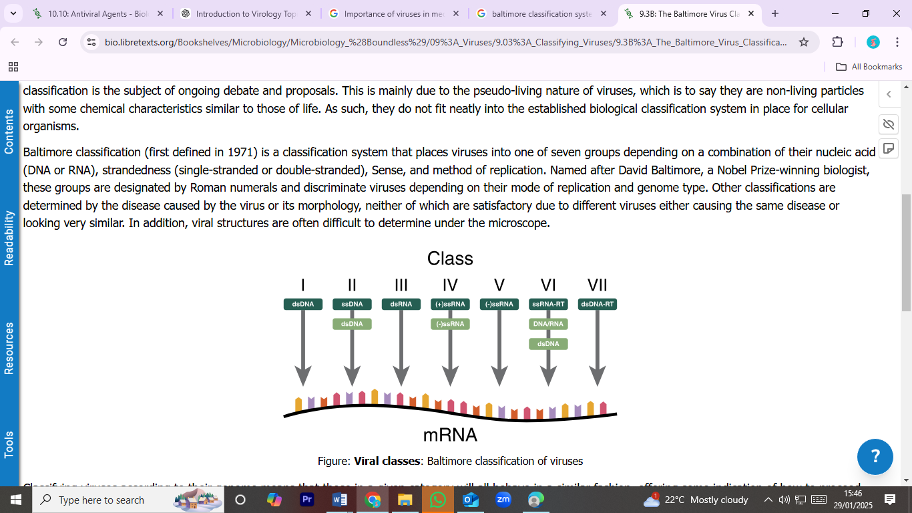

VIRUS CLASSIFICATION BY GENOME TYPE
- DNA viruses
  - The naked DNA viruses with an icosahedral symmetry are Family:
- Parvoviridae: Parvovirus B19 is spread by close physical contact. It causes erythema infectiosum or fifth disease.
- Papillomaviridae: Human papillomavirus causes warts in humans and is associated with cervical cancer
- Polyomaviridae: produces histologically diverse tumours in various parts of the body.
- Adenoviridae have more than 47 serotypes of adenovirus. This virus causes infection of the respiratory tract (nasopharyngitis); the eye (keratoconjunctivitis); and the intestines (e.g., diarrhea, vomiting).
- Hepadnaviridae have a tropism for infection of the liver e.g. Hepatitis B virus is also known as serum hepatitis and chronic hepatitis. Transmission of the virus is through the parenteral route (e.g., intravenous drug abuse and contaminated blood products) and sexual intercourse.

  - The enveloped DNA virus with icosahedral symmetry
Herpesviridae can become latent after the primary Infection e.g. herpes simplex 1 (HSV-1), herpes, simplex 2 (HSV-2), and varicella-zoster virus.
- HSV-1 is usually seen on the lips or skin or as an eye lesion.
- HSV-2 affects the genital or lips area and is frequently transmitted sexually. Neonatal herpes is a severe disease of the newborn caused by contact with the virus during passage through an infected birth canal.
- Varicella zoster virus causes a primary disease (chickenpox) and a recurrent disease (shingles).
- Chickenpox is a mild, self-limiting, highly infectious disease that occurs mainly in children.
- Shingles (or zoster) is caused by the reactivation of varicella zoster virus that has been latent in the neurons. Severely painful vesicles form on the trunk area.

3. DNA viruses with a complex symmetry.
Human viruses: vaccinia, variola, and molluscum contagiosum.
- Vaccinia is a variant of the variola virus and produces a mild disease. Vaccinia is used as the immunogen in the smallpox vaccination.
- The variola virus is the causative agent of smallpox, a disease that the World Health Organization presumes to be eradicated.
- Molluscum contagiosum causes small wart-like lesions on the face, arms, buttocks, and genitals.

- RNA viruses
    - The enveloped RNA viruses with helical symmetry:
Orthomyxoviridae, Paramyxoviridae, Arenaviridae, Rhabdoviridae, Coronaviridae, and Bunyaviridae.
- Orthomyxoviruses: They are influenza viruses and are classified as types A, B, and C.Types A and B are responsible for the epidemics of respiratory tract infections while Reye’s syndrome is associated with influenza type B.
- Paramyxoviridae: are divided into three genera: paramyxoviruses, morbilliviruses, and pneumoviruses. The paramyxoviruses are associated with the parainfluenza and mumps. Parainfluenza virus causes croup in infants. The mumps virus results in a generalized disease associated with enlargement of the parotid glands. The morbillivirus is associated with the measles virus and causes a rash, fever, and Koplik’s spots on the buccal mucosa. The pneumovirus responsible for bronchiolitis and pneumonia in infants
- Arenaviridae are responsible for hemorrhagic fevers and flu.
- Rhabdoviruses are bullet-shaped viruses associated with the human pathogenic rabies virus. The rabies virus produces a fatal disease following inoculation by a dog bite.
- Coronaviruses are the second most frequent cause of the common cold and have been implicated in infant gastroenteritis. Severe acute respiratory syndrome
- Bunyaviridae are the Hanta virus - associated with severe life-threatening respiratory tract infections.

2. The enveloped RNA viruses with icosahedral symmetry
the rubella virus, which causes German measles The rubella virus can produce congenital infections that can cause severe birth defects. The Flaviviridae include the dengue virus, hepatitis C, St. Louis encephalitis virus, yellow fever virus, and West Nile virus. Dengue virus is an arbovirus transmitted by mosquitoes. Yellow fever virus is an arbovirus transmitted by mosquitoes.

TheRetroviridae contain a reverse transcriptase enzyme—RNA-dependent DNA polymerase. This family contains lentiviruses. The lentivirus genus contains HIV-1 and HIV-2, which are the causative agents of AIDS. Transmission is through sexual intercourse, intravenous drug use, or transplacental from mother to child. Full-blown AIDS is characterized by Kaposi’s sarcoma, Pneumocystis carinii pneumonia and AIDS-related dementia.

  - The naked RNA viruses with icosahedral symmetry
Picornaviridae

Picornaviruses
They are classified as enteroviruses or rhinoviruses.

Enteroviruses
They include the polioviruses, coxsackievirus types A and B, echoviruses, enteroviruses, and the hepatitis A virus.

(a) The poliovirus
- can cause a mild illness, aseptic meningitis, or poliomyelitis (poliovirus types 1, 2, or 3).
- Spinal cord motor neurons are killed, and flaccid paralysis results.
- Diagnosis is through serologic testing or cultivation of the virus from throat culture or faeces.

(b) Coxsackievirus type A infections are associated with the following diseases: hand-foot-and-mouth disease, hemorrhagic conjunctivitis, aseptic meningitis, and colds.

(c) Coxsackievirus type B infections are associated with the following diseases: herpangina, viral heart disease, and Bornholm disease (pleurodynia).

(d) Echovirus primarily infects the enteric tract but can cause a range of diseases from the common cold to meningitis and hemorrhagic conjunctivitis.

(e) Enterovirus infections are associated with respiratory tract infections, central nervous system disease, and hemorrhagic conjunctivitis.

(f) Hepatitis A virus (HAV) is also called infectious hepatitis.
(i) Transmission is via the fecal-oral route.
(ii) Infections can cause epidemics.
(iii) HAV is diagnosed serologically by a rise in IgM detected by ELISA. PCR

Rhinoviruses
They are the most frequent cause of the common cold. More than 100 serotypes exist.

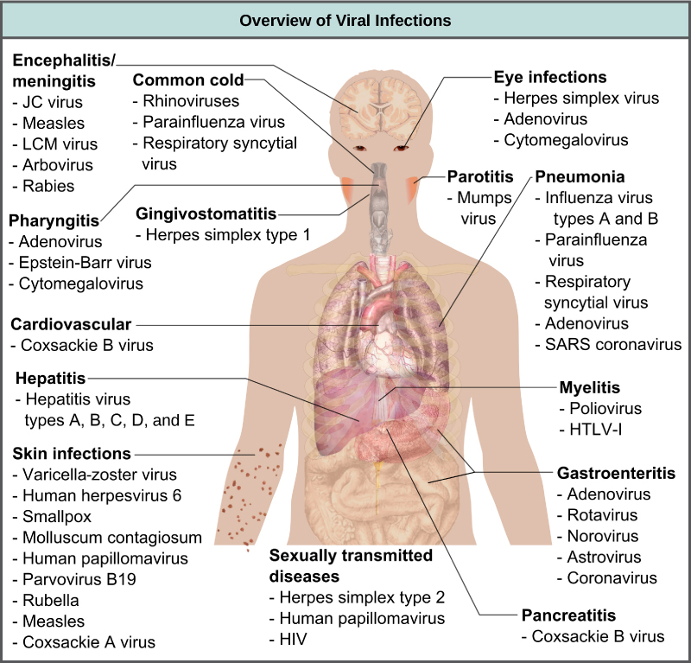

VIRUS KILLING AGENTS
Virus-killing agents, or disinfectants, are chemicals that can kill viruses and bacteria on surfaces. Some examples of virus-killing agents include:
- Sodium hypochlorite (JIK): An oxidizing agent that can inactivate viruses
- Hydrogen peroxide: An oxidizing agent that can inactivate viruses
- Peracetic acid: An oxidizing agent that can inactivate viruses
Disinfectants use oxidizing agents to inactivate viruses. The effectiveness of a disinfectant depends on the type of virus. For example, enveloped viruses are easier to kill than non-enveloped viruses.

Emerging Viral Infections
These are newly identified viruses or previously known viruses that have recently increased in incidence or geographic range.
- Coronaviruses (SARS, MERS, COVID-19): SARS-CoV-2 (2019-present): Cause of COVID-19 pandemic, originating from Wuhan, China.
- Ebola Virus - Causes severe hemorrhagic fever with high fatality rates.
- Zika Virus: Originally identified in 1947 but emerged as a global concern in 2015-2016 – spread by mosquito bites.
- Avian Influenza (H5N1, H7N9, H5N8): Highly pathogenic strains of influenza affecting birds and occasionally humans.
- Chikungunya Virus - Spread by Aedes mosquitoes, causes fever, rash, and joint pain. Originated in Africa now in America
- Crimean-Congo Hemorrhagic Fever: Tick-borne virus causing severe hemorrhagic fever.

Re-Emerging Viral Infections
These are viruses that were previously controlled or had declined but are now increasing
- Measles Virus: Preventable through vaccination but resurging due to vaccine hesitancy.
- Poliovirus: Nearly eradicated but persists in regions with low vaccination coverage (e.g., Afghanistan, Pakistan).
- Dengue Virus - Re-emerging in regions where it was previously under control.
- Yellow Fever Virus: Vaccine-preventable but resurging due to insufficient vaccination coverage.
- Influenza Virus (Seasonal and Pandemic Strains) - The 2009 H1N1 pandemic was a re-emergence of a novel swine-origin flu virus.
- Rabies Virus Re-emerging in areas with declining control programs.

Factors that contribute to the emergence and re-emergence of infectious diseases:
- Human behaviour: This includes changes in individual and societal behavior. Cultural practices e.g. sexual practices, travel
- Globalization: This includes international travel and commerce.
- Environmental change: This includes changes in land use and ecosystems.
- Economic development: This includes the impact of poverty and social inequity.
- Public health: This includes the breakdown of public health measures and systems - Weak disease monitoring systems hence delayed detection. Poor Healthcare Access: Limited healthcare resources can exacerbate the spread and impact of infections. Vaccine Hesitancy: (e.g., measles).
- Microbial adaptation: through Mutation and Recombination - RNA viruses (e.g., influenza, HIV) have high mutation rates, enabling them to evade immunity or jump species. Viruses switch host (e.g., SARS-CoV-2 likely originated in bats). Overuse of antiviral drugs can lead to resistant strains.
- This includes the ability of microbes to change and adapt.
- Technology and industry: the impact of new research and technology.
- Demographics: This includes changes in global population demographics. Migration, conflicts, displacement and poverty.
- Bioterrorism: This includes the deliberate release of viruses, bacteria, or other agents to cause illness or death.

Mitigation Strategies
- Strengthen global surveillance and early warning systems.
- Invest in research on zoonotic diseases and viral evolution.
- Promote sustainable land use and wildlife conservation.
- Improve public health infrastructure and access to healthcare.
- Enhance international cooperation for outbreak response and vaccine distribution.

ICTV CLASSIFICATION

